**Experiment No:** 06

**Experiment Title:** Shell script commands: File handling, Text Processing and System Administration

**Theory:**

**Pwd:** Use the pwd command to find out the path of the current working directory.

**Cd:** It requires either the full path of the name of the directory.

**Is:** is command is used to view the contents of a directory.

**Cp:** Use the cp command to copy file from the current directory to a different directory.

**Mv:** The primary use of the mv command is to move files, although is can also be used to rename files.

**Mkdir:** Use mkdir command to make a new directory.

**Touch:** The touch command allows you to create a blank new file through the linux command line.

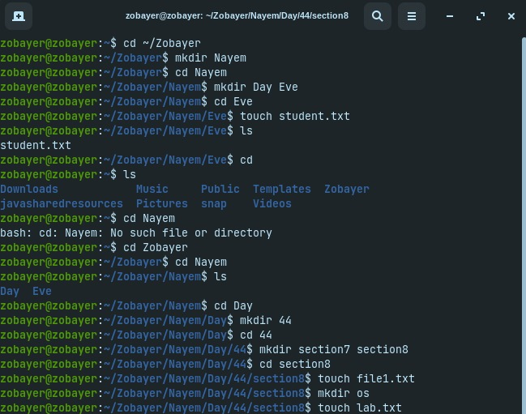**Code:**

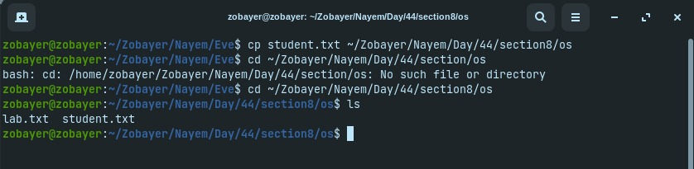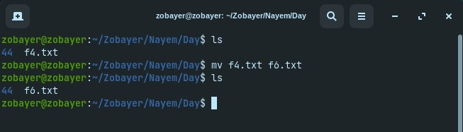

**Output:**

